# AI Assisted Coding

**Name:** N.Vishwas

**Roll Number:** 2403A510E4

**Batch:** 24BTCAICSB05

**Task Description #1**

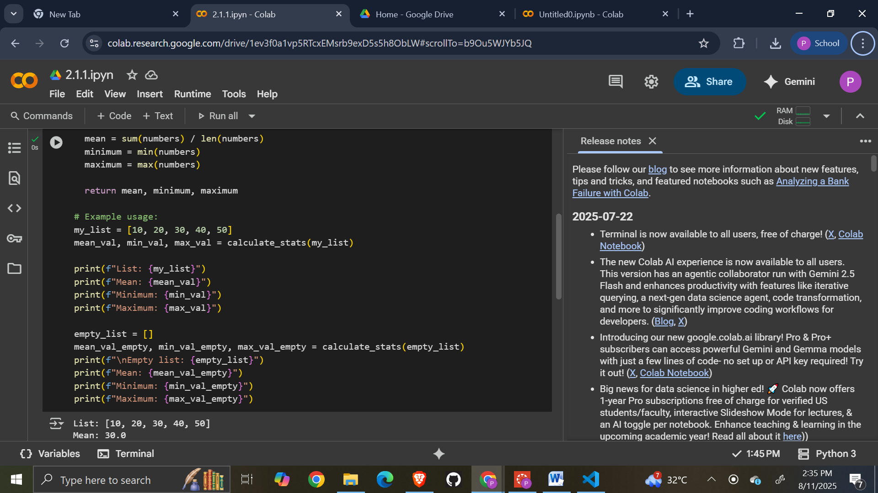

**Task Description #2**

GEMINI:

## 

## 

## CO-PILOT:

COMPARISION: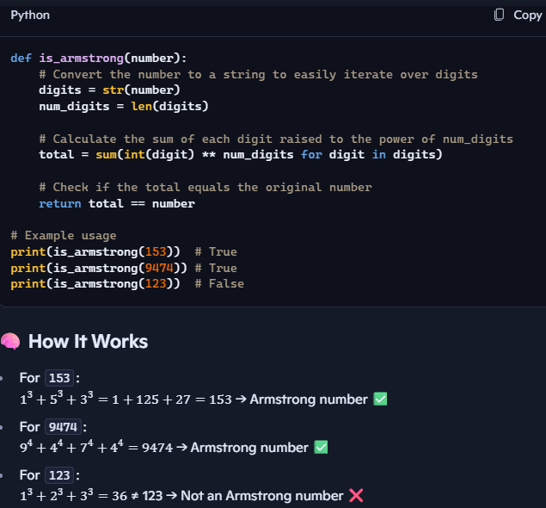

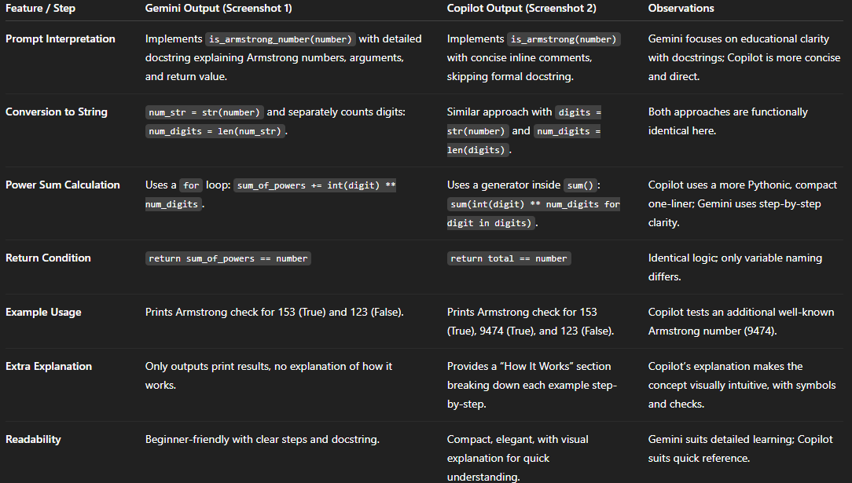

**Task Description #3**

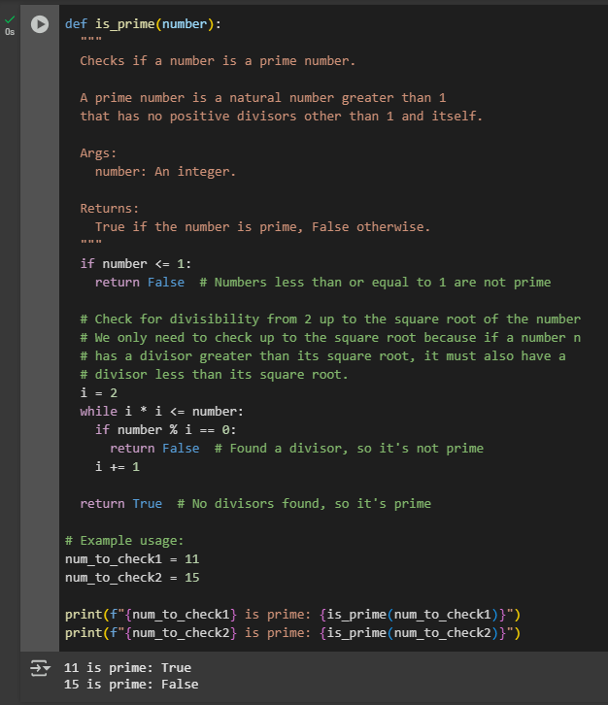

LINE BY LINE EXPLANATION:

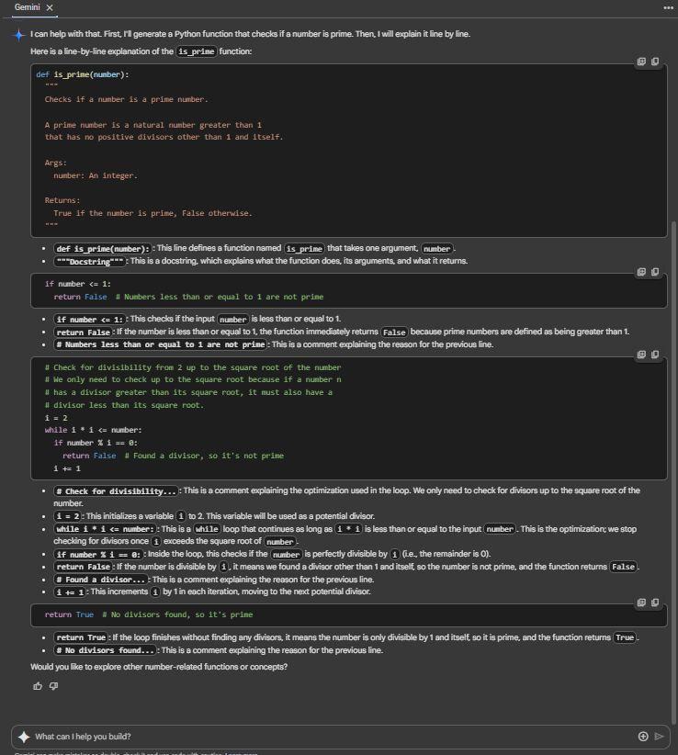

**Task Description #4**

**Cursor AI setup:**



**Prompts used:**

**Generate a Python function which gives the sum of the first n Natural numbers.**

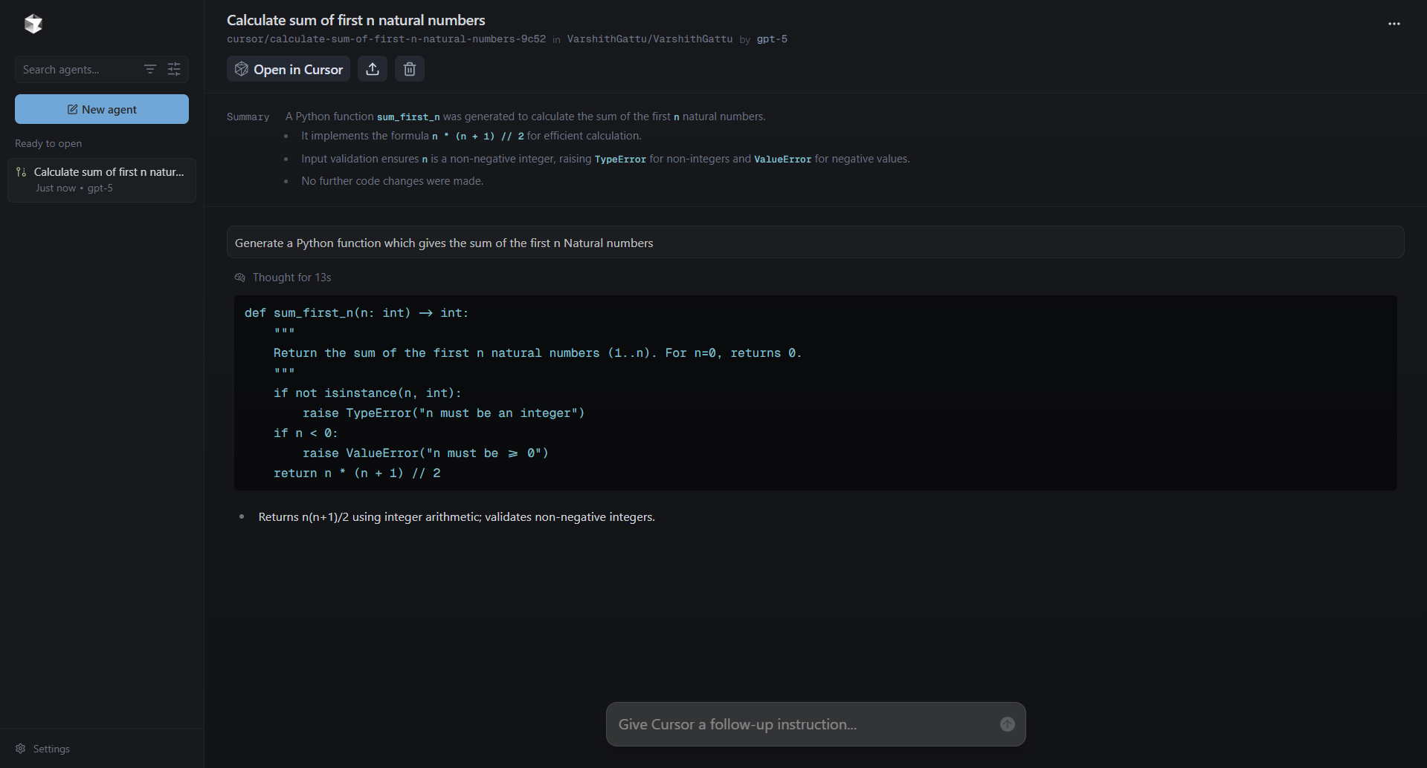

**Task Description #5**

**Original basic code:**

numbers = (1, 2, 3, 4, 5, 6, 7, 8, 9, 10)

even_sum = 0

odd_sum = 0

for num in numbers:

if num % 2 == 0:

even_sum += num

else:

odd_sum += num

print("Sum of even numbers:", even_sum)

print("Sum of odd numbers:", odd_sum)

**Sample Output:**

Sum of even numbers: 30

Sum of odd numbers: 25

**Refactored code:**

def sum_even_odd(nums):

even_sum = sum(n for n in nums if n % 2 == 0)

odd_sum = sum(n for n in nums if n % 2 != 0)

return even_sum, odd_sum

numbers = (1, 2, 3, 4, 5, 6, 7, 8, 9, 10)

even_total, odd_total = sum_even_odd(numbers)

print(f"Sum of even numbers: {even_total}")

print(f"Sum of odd numbers: {odd_total}")

**Sample Output:**

Sum of even numbers: 30

Sum of odd numbers: 25

**Explanation of refactored code:**

**Line 1:** Comment describing what the code does — calculates the sum of odd and even numbers in a tuple.

**Line 3:** Defines a function sum_even_odd with one parameter nums, which is expected to be a tuple of integers.

**Line 4:** A **docstring** explaining that the function returns the sum of even and odd numbers from the given tuple.

**Line 5:** Uses the sum() function with a generator expression to add up all numbers n in nums that are divisible by 2 (n % 2 == 0), meaning they are even.

**Line 6:** Similarly, sums up all numbers n in nums that are not divisible by 2 (n % 2 != 0), meaning they are odd.

**Line 7:** Returns both even_sum and odd_sum as a tuple.

**Line 10:** Creates a sample tuple numbers containing integers from 1 to 10.

**Line 13:** Calls sum_even_odd(numbers) and stores the two returned values in even_total and odd_total.

**Line 16:** Prints the sum of even numbers using an f-string for clear formatting.

**Line 17:** Prints the sum of odd numbers using an f-string.

**Output Screenshot:**

